How to Help Your Horse Have a Healthy Skin & Coat
Drs. Foster & Smith Educational Staff
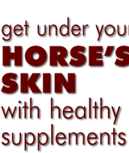 | 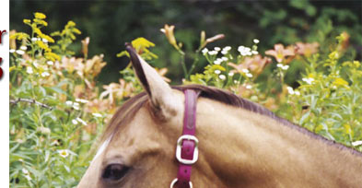
The condition of a horse's coat and skin are generally a reflection of his overall health. A healthy horse will have a shiny, even haircoat without excess oiliness or dryness. His winter coat will be longer and thicker, and should shed out completely in the spring. | 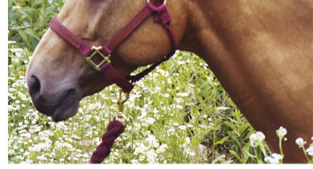
Understanding skin anatomy and function
The skin is the largest and one of the most important organs of the horse's body, making up 12-24% of his total weight. It varies from 1-1/2 inches thick on the lower back and rump, to less than 1/2 inch on the head and underbelly. The skin is made up of layers of cells. The tough outer covering is called the "epidermis" and the deeper layer called the "dermis."
Epidermis
The epidermis is composed of older cells that form a tough, almost impervious, protective outer barrier. As the outer cells erode, other cells mature and move up to replace them. The epidermis varies in thickness. The more exposed areas, such as the head and back, are thicker than areas such as the armpits and belly.
Dermis
The deeper layer (dermis) contains hair follicles, sebaceous (oil) glands, muscles, blood vessels, and nerves. Each hair follicle includes a root and the shaft of hair. There are two basic hair sizes. The larger hairs, which serve as the outer coat, are called the "guard" hairs. The smaller and more numerous hairs serve as the inner coat. Microscopic sebaceous glands produce and then secrete oils into the hair follicles. The oils work their way up the follicle and over the skin, helping to lubricate the skin and prevent excessive drying. Tiny muscle fibers are associated with each follicle. These can raise the hairs (a process called piloerection), allowing more air between them and increasing their insulation quality. Blood vessels carry nutrients to the cells, take away the wastes, and as they dilate and constrict, can help conserve or dissipate heat. Nerves in the skin help the horse to sense his environment - temperature, touch, pain, etc.
The hair of a horse does not grow continuously, but in cycles, similar to our eyebrows. Anagen is the first phase, in which the hair is produced. It grows along side the old hair, which is subsequently lost. Telogen is the resting phase in which the follicle is basically dormant, and the hair has actually died, but has not yet been shed. Catagen is the intermediate stage between anagen and telogen. The shedding of the hairs is mainly influenced by the amount of daylight, and to a smaller degree, by the temperature.
Causes of dry skin and dull coats
Since the skin and coat are so visible, disorders are readily detected during an examination. Dry skin or a dull haircoat can be caused by a number of conditions including:
The skin and hair of a horse have many functions including:
- Serving as the first barrier against injuries, chemicals, diseases, and the elements
- Regulating body temperature
- Preventing excess loss of moisture and thus maintaining hydration
- Synthesizing Vitamin D
- Sensory perception (the sense of touch)
- Hormonal imbalances
- Parasites, both internal and external
- Allergies
- Poor nutrition (e.g., low protein, diet poor in fatty acids)
Managing dry skin and dull coats
If your horse has an unhealthy coat or skin condition, work with your veterinarian to find the underlying cause. Once diagnosed, you can develop a management plan that may include:
- Treating any underlying medical condition
- Starting a regular worming and parasite prevention program
- Grooming your horse regularly - removing the dead hair and skin flakes and distributing the natural oils through the coat
- Shampooing with the appropriate product for your horse's particular condition
- Supplementing or correcting the diet and balancing your horse's ration to include at least 12% protein and ensuring adequate amounts of fat
Common ingredients in skin supplements
The most common ingredients in skin supplements include:
- Vitamin A, especially if there is no access to pasture - necessary for the production and maintenance of healthy skin and hair
- B vitamins, including Vitamin B6 (pyridoxine)
- Biotin - a vitamin necessary for the health and growth of skin and connective tissues
- Methionine - an amino acid essential for the growth of healthy skin
- Lysine - another amino acid necessary for healthy skin and coat
- Zinc - a mineral that is an antioxidant and is necessary for the proper production of proteins that are present in skin, hair, and hooves
- Fatty acids - important building blocks for healthy skin and coat
- Vitamin E - an antioxidant and vitamin essential for the production and maintenance of healthy skin; more Vitamin E is needed as more fats are added to the diet

